Sahil Gawande

B05

2016bec006

import numpy as np

import matplotlib.pyplot as plt

import cv2

a=cv2.imread('computer.jpg',0)

b=cv2.imread('mouse.jpeg',0)

c=np.add(a,b)

plt.subplot(1,3,1)

plt.imshow(a, cmap='gray')

plt.subplot(1,3,2)

plt.imshow(b, cmap='gray')

plt.subplot(1,3,3)

plt.imshow(c, cmap='gray')

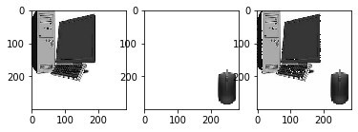

d= cv2.imread('Fig0228(a)(angiography_mask_image).tif')

e= cv2.imread('Fig0228(b)(angiography_live_ image).tif')

f=np.subtract(d,e)

plt.subplot(1,3,1)

plt.imshow(d, cmap='gray')

plt.subplot(1,3,2)

plt.imshow(e, cmap='gray')

plt.subplot(1,3,3)

plt.imshow(f, cmap='gray')

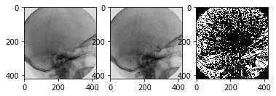

g=cv2.imread('lena.png',0)

h=cv2.imread('img5.png',0)/255

i=np.multiply(g,h)

plt.subplot(1,3,1)

plt.imshow(g, cmap='gray')

plt.subplot(1,3,2)

plt.imshow(h, cmap='gray')

plt.subplot(1,3,3)

plt.imshow(i, cmap='gray')

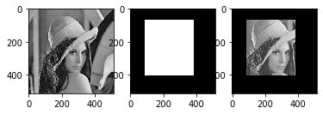

img1 = cv2.imread("drawing_1.png")

img2 = cv2.imread("drawing_2.png")

bit_and = cv2.bitwise_and(img2, img1)

bit_or = cv2.bitwise_or(img2, img1)

bit_xor = cv2.bitwise_xor(img1, img2)

bit_not = cv2.bitwise_not(img1)

bit_not2 = cv2.bitwise_not(img2)

plt.subplot(2,3,1)

plt.imshow(img1, cmap='gray')

plt.title('Image 1')

plt.subplot(2,3,2)

plt.imshow(img2, cmap='gray')

plt.title('Image 2')

plt.subplot(2,3,3)

plt.imshow(bit_and, cmap='gray')

plt.title('Bitwise AND')

plt.subplot(2,3,4)

plt.imshow(bit_or, cmap='gray')

plt.title('Bitwise OR')

plt.subplot(2,3,5)

plt.imshow(bit_xor, cmap='gray')

plt.title('Bitwise XOR')

plt.subplot(2,3,6)

plt.imshow(bit_not2, cmap='gray')

plt.title('Bitwise NOT')

plt.subplots_adjust(hspace=0.25, wspace=0.35)

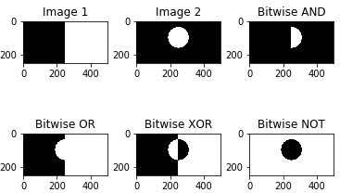

img1 = cv2.imread("drawing_1.png",0)

img2 = cv2.imread("drawing_2.png",0)

i0 = np.int32(np.array(np.zeros([250,500])))

c1 = np.int32(np.array(np.zeros([250,500])))

c2 = np.int32(np.array(np.zeros([250,500])))

c3 = np.int32(np.array(np.zeros([250,500])))

c4 = np.int32(np.array(np.zeros([250,500])))

b1 = np.int32(np.array(np.zeros([250,500])))

b2 = np.int32(np.array(np.zeros([250,500])))

for i in range(250):

for j in range(500):

b1[i][j] = np.binary_repr(img1[i][j])

b2[i][j] = np.binary_repr(img2[i][j])

for i in range(250):

for j in range(500):

c1[i][j] = (b1[i][j] and b2[i][j])

c2[i][j] = (b1[i][j] or b2[i][j])

c3[i][j] = (b1[i][j] ^ b2[i][j])

c4[i][j] = not(b1[i][j])

plt.subplot(2,3,1)

plt.imshow(img1, cmap='gray')

plt.title('Image 1')

plt.subplot(2,3,2)

plt.imshow(img2, cmap='gray')

plt.title('Image 2')

plt.subplot(2,3,3)

plt.imshow(c1, cmap='gray')

plt.title('Bitwise AND')

plt.subplot(2,3,4)

plt.imshow(c2, cmap='gray')

plt.title('Bitwise OR')

plt.subplot(2,3,5)

plt.imshow(c3, cmap='gray')

plt.title('Bitwise XOR')

plt.subplot(2,3,6)

plt.imshow(c4, cmap='gray')

plt.title('Bitwise NOT')

plt.subplots_adjust(hspace=0.25, wspace=0.35)

